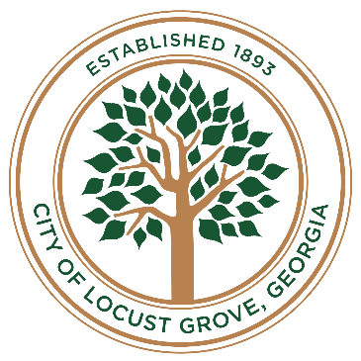

**Downtown development authority**

**Regular MEETING**

**November 7, 2023, 6:00 PM**

**LOCUST GROVE City Hall**

**3644 Hwy 42 Locust Grove, GA**

**POSTED Agenda**

* **Welcome**
* **Determination of quorum**
* **Approval of Minutes** 
  + 1. October 3, 2023
* **Reports**
  1. Development Report
  2. Main Street Report

* **Old Business**

1. Property acquisition plans
2. Carter Lot update
3. DDA board member replacement
4. Land lease agreement

* **New Business**

1. Christmas…in the Grove
2. Main Street Program Workshop

* **DDA Comments**
* **Public Comments**

* **Executive Session (if needed)**
* **Adjournment**